**Salesforce Agile Accelerator**



A Free Salesforce AppExchange Product utilized for Project and User story Management in Agile Methodology with free of user License and Maintenance.

Documented by,

Kolvan Corporation.

**CONTENT**

|  |  |  |
| --- | --- | --- |
| **S. No** | **Name** | **Page No.** |
| 1 | Introduction | 3 |
| 2 | Key benefits of Agile Accelerator | 4 |
| 3 | Kanban in Agile Accelerator | 5-7 |
| 4 | Life Cycle of Agile Accelerator | 8 |
| 5 | Manage Agile Teams | 9 |
| 6 | Manage Agile Product Tags | 10-11 |
| 7 | Manage Epics | 12-13 |
| 8 | Manage Agile Sprints | 14-15 |
| 9 | Manage Themes | 16 |
| 10 | Installation & Configuration | 17-21ß |

**Introduction**

Salesforce has been recognized multiple times for being the most innovative company in the world. Two of the biggest ways we stay innovative is our Agile mind-set and using our own products. Salesforce has been practicing the Agile process for over six years. At the core of our Agile process is Agile Accelerator. Internally we call it Grand Unification System (GUS). As our single source of truth, it provides us with team visibility throughout the company and helps us quickly collaborate on work. We’ve taken the most popular features in GUS and packaged it up for our customers.

What is Agile Accelerator:

Salesforce Agile Accelerator helps you manage your agile product development with the same technology that’s used in your Salesforce organization. Your entire team can track user stories, bugs, reports, and more from within Salesforce. For added flexibility, Kanban is supported. Use it together with Scrum, or by itself.

With Salesforce Agile Accelerator, your information is secure and fully integrated with other Salesforce apps, such as Sales Cloud and Service Cloud. You can connect user stories and bugs to CRM cases and accounts. Because Salesforce Agile Accelerator runs on the Salesforce1 platform, your team is mobile and social with the Salesforce1 mobile application. You can also integrate to other systems and easily extend the Salesforce Agile Accelerator to meet any business process.

Salesforce Agile Accelerator comes with a default team, product tag, and several reports and dashboards for you to use in testing.

Note: By default, the sample reports located in the Agile Accelerator folder are available only to the administrator who installed the package. The administrator can share the reports with individual users, public groups, or roles.

**Key Benefits of Agile Accelerator**

* Agile Project Management: one single application, the Salesforce Platform
* Free of cost, Can be downloaded and maintain with free of charge.
* Can be able to expand the components and design as needed.
* Collaboration: work in context with your peers using Chatter
* Leverage Expertise: tool built by Salesforce Agile teams for Agile Organizations
* Ability to integrate backlogs with standard Salesforce objects like Accounts/Cases etc. is super-efficient and easy.
* Provide tracking options for backlog or sprints in Kanban view on both mobile and desktop.

**Kanban in Agile Accelerator**

**Kanban** is a system for visualizing the work for a team. You can view how things are progressing, eliminate bottlenecks, and improve the delivery process. Kanban helps you monitor work items at various stages of development.

**Kanban is based on four basic principles.**

• Visualize what you work on today (workflow) See all your work in one place is informative.

• Limit the amount of work in progress (WIP) Assign limits to how many items can be in progress at once for a given workflow state.

• Measure cycle time Balance the average time to complete one item with delivering quality and value.

• Continuous improvement After a Kanban system is in place, it becomes the cornerstone for a culture of continuous improvement. Teams measure their effectiveness by tracking flow, quality, throughput, lead times, and more.

**Why Kanban?**

Knowledge workers often suffer from frequent interruptions, task switching, and excessive multitasking. To prevent this, Kanban limits overburdening by letting people pull work only when they have capacity. Kanban enables workers to focus on completing small batches of tasks and avoid bottlenecks. Emphasizing workflow creates a balance between the team’s capacity, the demands that are placed on it, and the desire to improve speed and quality.

**How Is Kanban Different from Scrum?**

Kanban Scrum Comparison Kanban

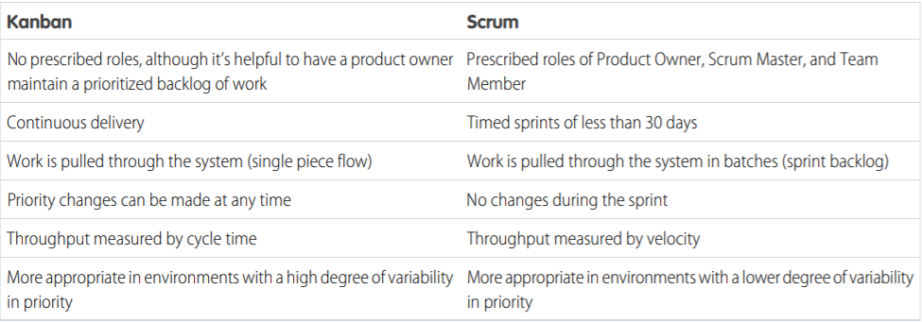

Some teamwork is not conducive to using Scrum. For example, a team who receives security vulnerabilities can’t easily plan a sprint because they aren’t able to predict the tickets they will receive. If they employ a Kanban approach to continually prioritize the work, they can limit their WIP to maximize throughput, efficiency, quality, and customer satisfaction.

You can create Kanban boards with the Salesforce Agile tool. The board can co-exist with your regular Scrum team, a process called ScrumBan. Layering Kanban on top of your existing process helps expose bottlenecks and waste and optimize the flow of work for your team.

**Create a Kanban Board**

You create Kanban boards by adding the Kanban tab to your organization. If the team already has a Kanban board, clicking the Kanban tab opens the board for editing.

1. If you don’t see the Kanban tab, add the tab to your organization. Click at the end of your organization’s tabs.

2. Click Customize My Tabs.

3. Scroll down and select Kanban.

4. Click the Kanban tab and select which team you want to create the Kanban board for.

5. Select Create Kanban Board. A new Kanban board appears with several columns, which you can modify or add to.

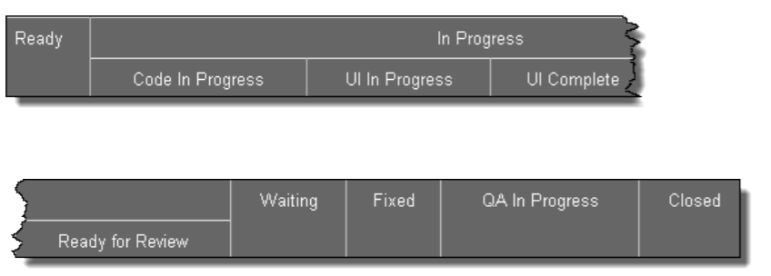

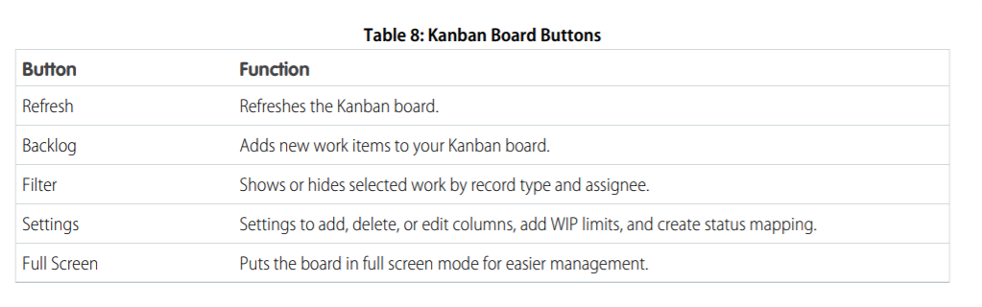

**Edit a Kanban Column**

You can customize your Kanban board columns to suit your organization.   
1. From your Kanban board, click Settings. The Kanban board edit screen appears.

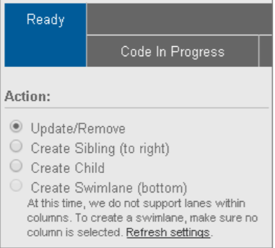  
2. Select a column and click Update/Remove to edit the column properties.

**Life Cycle of Agile Accelerator**

The below diagram explains the Step by Step Records creations in Agile Accelerator.

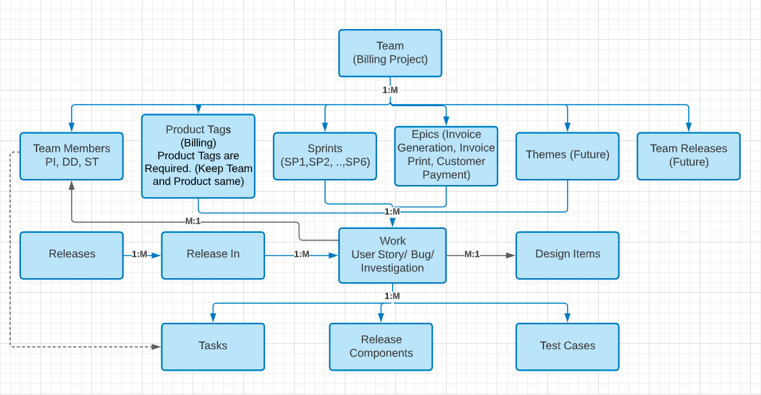

**Manage Agile Teams**

Agile teams include cross-functional members such as, software engineers, architects, programmers, analysts, QA experts, testers, and UI designers. You’ll need to define your teams as one of the first steps to using Agile. After team members are added, you can assign the role and the availability of each member.

**To create or edit a team:**

1. From within the application, click the Teams tab. From here you can either edit an existing team or create a new team.

2. To create a team, click the All Teams link at the top of the page.

3. When the list view appears, click New Team. Required fields appear with a red.

4. Choose a name and a cloud. The cloud name is the same as department.

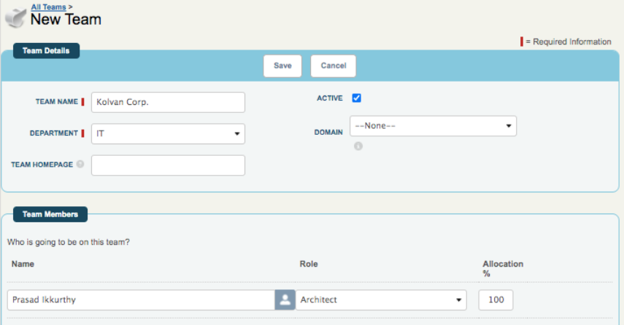

5. Enter the team members’ names, their roles, and their availability allocations. Although roles and allocation aren’t required, knowing a team member’s allocation is an important factor during sprint planning.

6. Enter a name for the Product Tag. A Product Tag is required to create user stories and bugs for the team. You can also create tags from the Product Tag tab. Product Tags drive assignment rules that allow you to automatically populate assignees on work records.

7. Click Save.

**Manage Agile Product Tags**

Product tags provide a way of organizing your work into logical categories. Product tags are unique for each team in your organization and are required when you’re creating work items.

So, you’ll need at least one product tag for each team. Product tags are typically used to represent product areas or departments but can represent whatever your organization decides.

For example, let’s say you have a small team that produces an application called Find Files. You can create a product tag called Find Files and use it with all work items. But what if the team is larger and produces your Find Files application for Android and iOS users? Half the team members work on iOS and the other half work on Android. You can then create two product tags called Find Files-iOS and Find Files-Android and use the two tags to separate the work for each group within the team.   
When you create a product tag, you must define at least one assignment rule. When work items are created, an assignment rule automatically assigns work items to team members based on the product tag. Requiring an assignment rule ensures that no work item gets lost or go unattended.

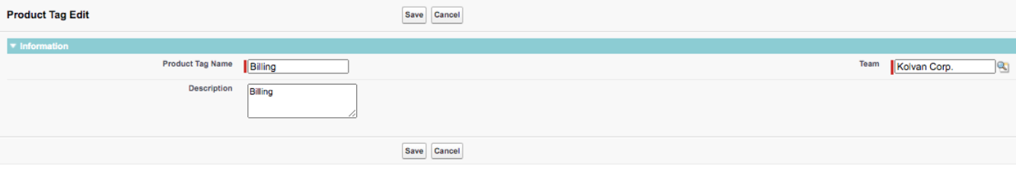

When you’re creating an assignment rule, the roles of assignee and product owner are required. You can also add other members of the team such as a specific QA engineer. For example, you can assign a developer, product manager, and QA engineer to the Find Files-iOS tag assignment rule and different people to the Find Files-Android rule. Team members can reassign the work item to other members of the team as needed, but the initial assignment is done by the assignment rule. Product tags are created from the Team page or from the Product Tag tab in the main menu bar

You can create Product tags to organize your team’s work into logical categories. Product Tags are created from the Team tab or the Product Tag tab and are required when you create work items.

All work items require the assignment of a Product Tag. So, make sure you create as least one tag for your team.

**To create a Product Tag:**

1. From your team’s page, click Product Tags and then New Product Tag. Alternatively, click the Product Tags tab from the menu bar and then New.

2. Enter a name for the Product Tag, and then click Save. The assignment rules page appears. Add at least one assignment rule to a Product Tag to ensure that no bug or user story goes unattended.

The assignment rules page appears. Add at least one assignment rule to a Product Tag to ensure that no bug or user story goes unattended

3. Click Create New to create an assignment rule.

4. Click the bug or user story icon to select the type of work item that rule affects. Note: You can create different rules for bugs and user stories, or you can choose to make the same assignment rule work for both types of work items. You can also choose any assignment rule that’s already on the list.

5. Enter the names of the assignees. Product Owner and Assignee are required fields.

6. Click Save

**Manage Epics**

An Epic is a large User Story that can’t be completed in a single sprint or sometimes even multiple sprints. Because Epics are large projects, Agile teams break them down into smaller, manageable User Stories.  
As an example, let’s use making a movie. The entire movie is the Epic, and each scene in the movie is a User Story. If you don’t break the movie into smaller parts, like scenes, it’s challenging to scope and manage things such as budget, actors, and filming time.

Some other examples of potential Epics where it's necessary to break the project into smaller parts to judge the **scope of the work are:**

• Creating a mobile application that tracks mobile visitors to your website for both iOS and Android   
• Creating a way to add users to Salesforce in bulk   
• Training users how to use a new software release   
As you split an Epic into smaller User Stories, you can use themes to group similar User Stories together. For example, when creating a mobile application for visitor tracking, organize your User Stories with an iOS theme and an Android theme.

**There are two options for adding an epic to a work record:**

• From within the Epic, click New Work.

• From within a User Story, enter the epic name in the Epic box on the detail page.

From the Epic’s detail page, you can see details about attachments, open activities, team dependencies, and work assigned. There are also burndown and burnup charts that show the remaining points assigned to the Epic and the number of closed and open records by date

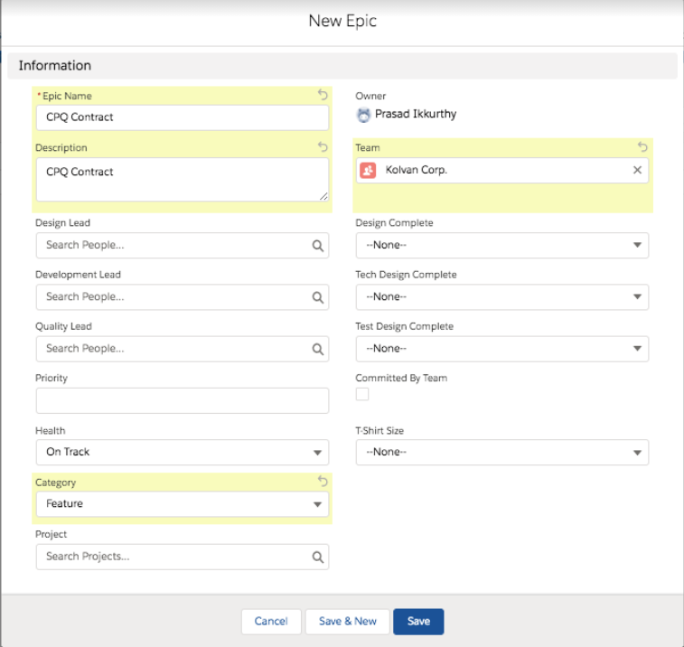

Example Report showing Story Points and Open Item graph

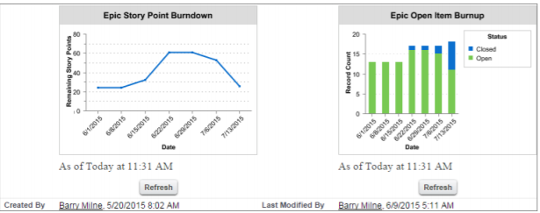

**Manage Agile Sprints**

Once you’ve got your team created, you’ll want to create your sprints to organize your work into manageable

Many teams use sprints that are two weeks long, but you can create any duration up to one month long. There’s a sample sprint on the Sprint tab that’s loaded with test data. If it’s the first time that you’ve viewed a sprint, you’re prompted to take a guided tour of the available features. You can skip the tour because you can click the Guided Tour link in the top right corner of the screen at any time.

**To create a sprint:**

1. Click the Sprint tab.

2. Click the List View link in the top left corner.

3. When the list view appears, click New Sprint.

4. Enter the name of the sprint. The suggested format is yyyy.mm.sprint number(a-f). team name.

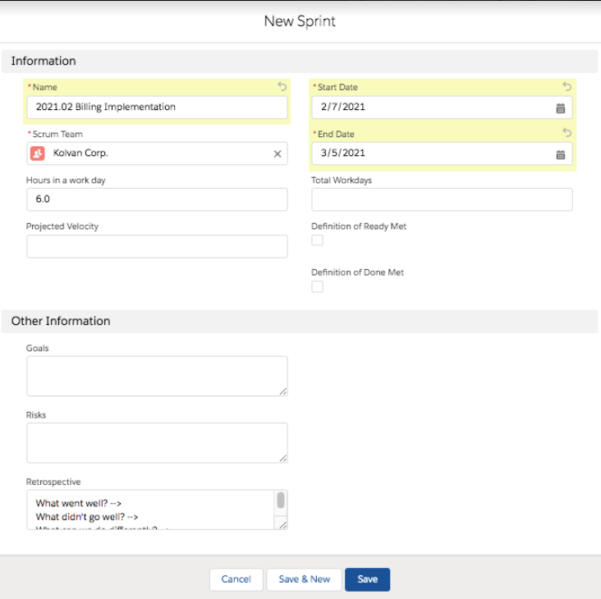

For example, if you have two-week sprints, the sprint that covered the first two weeks of February 2021 would be 2021.01a-MyTeamName

The second two weeks would be 2021.01b-MyTeamName. Following a naming convention helps with reporting later.

Note: You can change the sprint naming convention by modifying the validation rule on the Sprint object in Setup. From the object management settings for sprints, go to Validation Rules, and then modify or de-activate the Verify Name Format validation rule.

5. Enter the name of the agile team that you created earlier in the Agile Team field.

6. Populate the Start Date and End Date fields. Make sure that start and end dates don’t overlap with the dates of other sprints for your team. Again, a typical sprint is two weeks.

7. Click Save. Your virtual wall appears.

Note: You can sort the work records by Assignee and QA Engineer. Click the drop-down arrow next to the Assignee or QA Engineer fields in the header. Check the names of the people whose work you want to see.

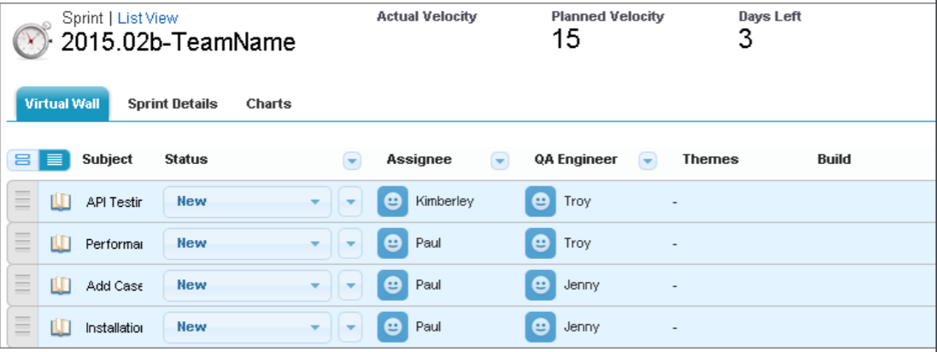

**Manage Themes**

Themes are a way to group similar User Stories together. Some people refer to them as tags. All the User Stories assigned to a theme are related, such as they all focus on a particular operating system or feature.

For example, let’s say that you’re working on a mobile Web application for both iOS and Android and you created a Theme for each operating system. You can assign Themes to work items and then use an assignment rule to assign them to particular team members. You can also create reports and dashboards based on Themes

There are two options for adding a theme to a work record:

• From within the Theme, click Add Work To Theme.

• From within a User Story, enter the theme name in the theme related list

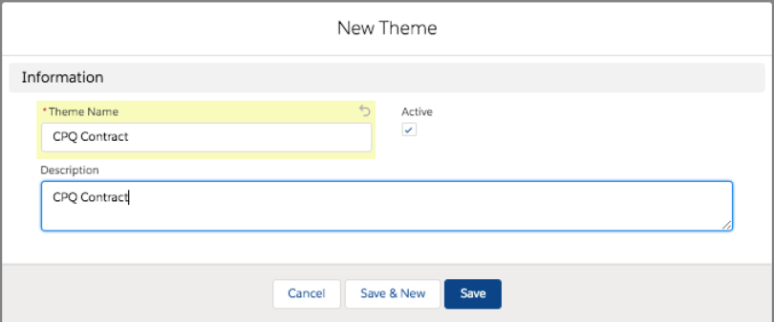

**Installation & Configuration**

**Step: 1 Install the App from AppExchange**

The Salesforce Agile Accelerator is available on the AppExchange as a managed package.   
URL: <https://appexchange.salesforce.com/listingDetail?listingId=a0N30000000ps3jEAA>

Note: While installing please select option for ‘Install for all users’.

1. From Setup, enter Apps in the Quick Find box, then select Apps to see the list of apps that are installed in your organization.

2. Look for the Salesforce Agile Accelerator installed package.

3. After you’ve verified the installation, select Salesforce Agile Accelerator from the Application Selector in the upper right corner. When you finish installing, assign permission sets.

**Step: 2 Assign Permission Sets**  
Assign managed package permissions to users in salesforce as per their level and role of access needed.  
With the package installation there are 2 permission sets also get deployed in same time.

Salesforce Agile Accelerator has two permission sets that you can assign to users, one with administrative permissions and the other for non-administrators.   
1. From Setup, enter Users in the Quick Find box, then select Users.

2. Click the user’s name.

3. Scroll to the Permission Set Assignments related list.

4. Click Edit Assignments.

5. Select a permission set and click Add.

6. Click Save.

**Agile Accelerator Admin**

This permission to be assigned to users in salesforce who are manages Agile Accelerator like implementation teams PMO/SM/Developers etc.,

**Agile Accelerator User**

This permission to be assigned to users from Business and who can read the data and agile process.

**Step: 3 Deploy Custom Components Created**

Every organization can have different information and categorization process. So, we need to design Customization on Agile accelerator extending on top of what has be installed through package.

Part of this Customization and better adoptability of the tool, we have developed below customized Components.

Shared Link: <https://github.com/kolvan-corporation/Agile-Accelerator>

**Step: 4 Post Configuration Steps**

[**1] Object Level Access:**

Provide access to below object the profiles needed to access/use Agile Accelerator.

|  |  |  |
| --- | --- | --- |
| **Object Name** | **Object Level Permission for Admin/Technical Team** | **Object Level Permission for Business User** |
| Design Item | Read/Create/Edit/View All/Delete/Modify All | Read/View All |
| Release Component | Read/Create/Edit/View All/Delete/Modify All | Read/View All |
| Test Case | Read/Create/Edit/View All/Delete/Modify All | Read/View All |

|  |  |  |
| --- | --- | --- |
| Deployment Step | Read/Create/Edit/View All/Delete/Modify All | Read/View All |

**[2] Tab Level Access:**Provide Tab Level ‘Default ON’ Access to all the profiles need to User Agile Accelerator.

|  |  |
| --- | --- |
| **Tab Name** | **Object Name** |
| Design Items | Design Item |
| Release Components | Release Component |
| Test Cases | Test Case |
| Deployment Step | Deployment Step |

**[3] Field Level Access:**

Provide access(read/Edit) to below object fields to profiles in object settings.

|  |  |  |  |  |
| --- | --- | --- | --- | --- |
| **Object Name(API)** | **Field Label** | **API Name** | **Data Type** | **Action** |
| agf__ADM_Work__c | [Business Analyst](https://enverus--sfbdev.my.salesforce.com/00N7c000001jw9O?setupid=CustomObjects) | Business_Analyst__c | Lookup(User) | Created |
| agf__ADM_Work__c | [Business Owner](https://enverus--sfbdev.my.salesforce.com/00N7c000001jw9T?setupid=CustomObjects) | Business_Owner__c | Lookup(User) | Created |
| agf__ADM_Work__c | [Business Validation Status](https://enverus--sfbdev.my.salesforce.com/00N7c000001jwCm?setupid=CustomObjects) | Business_Validation_Status__c | Picklist | Created |
| agf__ADM_Work__c | [Business Value](https://enverus--sfbdev.my.salesforce.com/00N7c000001jwCr?setupid=CustomObjects) | Business_Value__c | Picklist | Created |
| agf__ADM_Work__c | [Category](https://enverus--sfbdev.my.salesforce.com/00N7c000001jwCw?setupid=CustomObjects) | Category__c | Picklist | Created |
| agf__ADM_Work__c | [Dependency On](https://enverus--sfbdev.my.salesforce.com/00N7c000001jwD6?setupid=CustomObjects) | Dependency_On__c | Lookup(Team) | Created |
| agf__ADM_Work__c | [Dependency Reason](https://enverus--sfbdev.my.salesforce.com/00N7c000001jwDB?setupid=CustomObjects) | Dependency_Reason__c | Long Text Area(32768) | Created |
| agf__ADM_Work__c | [Design Item](https://enverus--sfbdev.my.salesforce.com/00N7c000001jwLZ?setupid=CustomObjects) | Design_Item__c | Lookup(Design Item) | Created |
| agf__ADM_Work__c | [Detailed Description](https://enverus--sfbdev.my.salesforce.com/00N7c000001jwLe?setupid=CustomObjects) | Detailed_Description__c | Rich Text Area(32768) | Created |
| agf__ADM_Work__c | [Environment](https://enverus--sfbdev.my.salesforce.com/00N7c000001jwLj?setupid=CustomObjects) | agf__Environment__c | Picklist (Multi-Select) | Updated |
| agf__ADM_Work__c | [Hold Reason](https://enverus--sfbdev.my.salesforce.com/00N7c000001jw9J?setupid=CustomObjects) | Hold_Reason__c | Long Text Area(32768) | Created |
| agf__ADM_Work__c | [Priority](https://enverus--sfbdev.my.salesforce.com/00N7c000001jwLo?setupid=CustomObjects) | Priority__c | Picklist | Created |
| agf__ADM_Work__c | [Region](https://enverus--sfbdev.my.salesforce.com/00N7c000001jwLt?setupid=CustomObjects) | Region__c | Picklist (Multi-Select) | Created |
| agf__ADM_Work__c | [Story Type](https://enverus--sfbdev.my.salesforce.com/00N7c000001jwLy?setupid=CustomObjects) | Story_Type__c | Picklist | Created |
| agf__ADM_Work__c | [Sub Category](https://enverus--sfbdev.my.salesforce.com/00N7c000001jwD1?setupid=CustomObjects) | Sub_Category__c | Picklist | Created |
| agf__ADM_Work__c | [Support Ticket](https://enverus--sfbdev.my.salesforce.com/00N7c000001jwM3?setupid=CustomObjects) | Support_Ticket__c | Text(40) | Created |
| agf__ADM_Work__c | [Technical Architect](https://enverus--sfbdev.my.salesforce.com/00N7c000001jwM8?setupid=CustomObjects) | Technical_Architect__c | Lookup(User) | Created |
| Design_Item__c | [Advantages](https://enverus--sfbdev.my.salesforce.com/00N7c000001jwDu?setupid=CustomObjects) | Advantages__c | Long Text Area(32768) | Created |
| Design_Item__c | [Design Approved On](https://enverus--sfbdev.my.salesforce.com/00N7c000001jwDQ?setupid=CustomObjects) | Design_Approved_On__c | Date/Time | Created |
| Design_Item__c | [Design Approver](https://enverus--sfbdev.my.salesforce.com/00N7c000001jwDV?setupid=CustomObjects) | Design_Approver__c | Lookup(User) | Created |
| Design_Item__c | [Design Submitted On](https://enverus--sfbdev.my.salesforce.com/00N7c000001jwDa?setupid=CustomObjects) | Design_Submitted_On__c | Date/Time | Created |
| Design_Item__c | [Detailed Description](https://enverus--sfbdev.my.salesforce.com/00N7c000001jwDp?setupid=CustomObjects) | Detailed_Description__c | Rich Text Area(32768) | Created |
| Design_Item__c | [Limitations](https://enverus--sfbdev.my.salesforce.com/00N7c000001jwDL?setupid=CustomObjects) | Limitations__c | Long Text Area(32768) | Created |
| Design_Item__c | [Proposed Solution](https://enverus--sfbdev.my.salesforce.com/00N7c000001jwDk?setupid=CustomObjects) | Proposed_Solution__c | Rich Text Area(32768) | Created |
| Design_Item__c | [Status](https://enverus--sfbdev.my.salesforce.com/00N7c000001jwDz?setupid=CustomObjects) | Status__c | Picklist | Created |
| Design_Item__c | [Subject](https://enverus--sfbdev.my.salesforce.com/00N7c000001jwE4?setupid=CustomObjects) | Subject__c | Text Area(255) | Created |
| Design_Item__c | [Technical Architect](https://enverus--sfbdev.my.salesforce.com/00N7c000001jwDG?setupid=CustomObjects) | Technical_Architect__c | Lookup(User) | Created |
| Design_Item__c | [Type](https://enverus--sfbdev.my.salesforce.com/00N7c000001jwEE?setupid=CustomObjects) | Type__c | Picklist | Created |
| Release_Component__c | [Audit Comments](https://enverus--sfbdev.my.salesforce.com/00N7c000001jwMr?setupid=CustomObjects) | Audit_Comments__c | Long Text Area(32768) | Created |
| Release_Component__c | [Auditor](https://enverus--sfbdev.my.salesforce.com/00N7c000001jwN1?setupid=CustomObjects) | Auditor__c | Lookup(User) | Created |
| Release_Component__c | [Audit Required?](https://enverus--sfbdev.my.salesforce.com/00N7c000001jwMh?setupid=CustomObjects) | Audit_Required__c | Picklist | Created |
| Release_Component__c | [Audit Status](https://enverus--sfbdev.my.salesforce.com/00N7c000001jwMm?setupid=CustomObjects) | Audit_Status__c | Picklist | Created |
| Release_Component__c | [Component API Name](https://enverus--sfbdev.my.salesforce.com/00N7c000001jwMX?setupid=CustomObjects) | Component_API_Name__c | Text(150) | Created |
| Release_Component__c | [Component Name](https://enverus--sfbdev.my.salesforce.com/00N7c000001jwMS?setupid=CustomObjects) | Component_Name__c | Text(100) | Created |
| Release_Component__c | [Component Type](https://enverus--sfbdev.my.salesforce.com/00N7c000001jwMw?setupid=CustomObjects) | Component_Type__c | Picklist | Created |
| Release_Component__c | Object | Object__c | Text Area(255) | Created |
| Release_Component__c | [Work](https://enverus--sfbdev.my.salesforce.com/00N7c000001jwMc?setupid=CustomObjects) | Work__c | Lookup(Work) | Created |
| Test_Case__c | [Description](https://enverus--sfbdev.my.salesforce.com/00N7c000001jwQF?setupid=CustomObjects) | Description__c | Rich Text Area(32768) | Created |
| Test_Case__c | [Status](https://enverus--sfbdev.my.salesforce.com/00N7c000001jwQA?setupid=CustomObjects) | Status__c | Picklist | Created |
| Test_Case__c | [Unique Number](https://enverus--sfbdev.my.salesforce.com/00N7c000001jwQ5?setupid=CustomObjects) | Unique_Number__c | Auto Number | Created |
| Test_Case__c | [Work](https://enverus--sfbdev.my.salesforce.com/00N7c000001jwVt?setupid=CustomObjects) | Work__c | Lookup(Work) | Created |
| Deployment_Step__c | Object | Object__c | Text Area | Created |
| Deployment_Step__c | Work | Work__c | Lookup(Work) | Created |
| Deployment_Step__c | Release Component | Release_Component__c | Lookup(Release Component) | Created |
| Deployment_Step__c | Step Details | Step_Details__c | Rich Text Area(32768) | Created |

|  |  |  |  |  |
| --- | --- | --- | --- | --- |
| Deployment_Step__c | Type | Type__c | Picklist | Created |

**[4] Page Layout Assignments:**

Please update Page layout Assignments to all Profiles and for All Record Types usingbelow Page layout names.

|  |  |
| --- | --- |
| **Object** | **Page Layout Name** |
| Work | User Story |
| Work | Bug Layout |
| Work | ToDo |
| Work | Investigation |
| Work | Bug Layout (Admin) |
| Work | Bug Template |
| Work | Bug Layout (QA Manager) |
| Test Case | Test Case Layout |
| Release | Release Layout |
| Epic | Epic Layout Feed Based |
| Team | Scrum Team Layout |
| Release Component | Release Component Layout |
| Team Member | Team Member Layout |
| Sprint | Sprint Layout |
| Product Tag | Product Tag Layout |
| Theme | Theme Layout |
| Design Item | Design Item Layout |

|  |  |
| --- | --- |
| Deployment Step | Deployment Step Layout |

**[5] Override Buttons with Standard:**

For the below mentioned objects and buttons in those objects Edit & Override them from Package components to Standard Salesforce page checkbox and save.

|  |  |
| --- | --- |
| **Object Name** | **Button Name** |
| Work | New |
| Work | Edit |
| Work | View |
| Sprint | New |
| Sprint | Edit |
| Sprint | View |
| Team | New |
| Team | Edit |
| Team | View |
| Team Members | New |
| Team Members | Edit |
| Team Members | View |
| Product Tag | New |
| Product Tag | Edit |
| Product Tag | View |
| Themes | New |
| Themes | Edit |
| Themes | View |
| Release | New |
| Release | Edit |
| Release | View |

**[6]. Lightning Record Pages:**

Open each Lightning Record Page mentioned below object and Activate Assignment as ‘Org Default’ By clicking on Activate Button.

|  |  |
| --- | --- |
| **Object Name** | **Record Page Name** |
| Team | [Team Detail Page](https://enverus--sfbdev.lightning.force.com/lightning/setup/ObjectManager/01I7c0000006CGz/LightningPages/0M07c0000000ITeCAM/view?0.source=alohaHeader) |
| Work | [Work Record Page(custom)](javascript:void(0);) |
| Sprint | [Sprint Wall](https://enverus--sfbdev.lightning.force.com/lightning/setup/ObjectManager/01I7c0000006CH4/LightningPages/0M07c0000000ITdCAM/view?0.source=alohaHeader) |
| Product Tag | [Product Tag Record Page](https://enverus--sfbdev.lightning.force.com/lightning/setup/ObjectManager/01I7c0000006CGm/LightningPages/0M07c0000000ITcCAM/view?0.source=alohaHeader) |
| Theme | [Theme Record Page](https://enverus--sfbdev.lightning.force.com/lightning/setup/ObjectManager/01I7c0000006CHC/LightningPages/0M07c0000000ITfCAM/view?0.source=alohaHeader) |